 

Q1:

Software Requirements Specification

for

Pet Medical Appointment System

Version 1.0 approved

Prepared by

Dao Quang Nguyen – HE176610

FU Hoa Lac

26/03/2024

Q2:

<Student must replace this line, answer Q2 by drawing 1 context diagram that reflect this exam paper and copy and then paste the image of that context diagram here

Notes:

1. Draw the correct syntax to describe the context diagram (0.3 point)
2. List the name of >= 4 external entities (0.6 point)
3. Draw the data flows described in this exam paper (1.6 points)

>

Q3:

< Student must replace this line

Notes:

1. Draw the correct syntax to describe the use case diagram (0.4 point)
2. List the name of >= 4 actors and brief descriptions (0.8 point)
3. Draw use cases and brief descriptions (2.8 points)

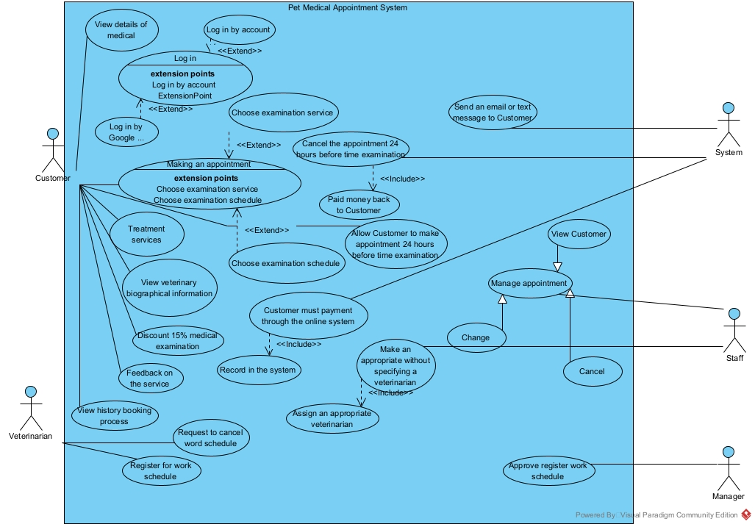

< Student must replace this line, **briefly describe** the actors of the diagram by fill the content to below table>

|  |  |  |
| --- | --- | --- |
| **#** | **Actor** | **Description** |
| 01 | Customer | The Customer can Login to system to View details medical, view veterinary, treatment service, feedback for service, view history booking process |
| 02 | Staff | Manage appointment make an appropriate without specifying a veterinarian to a assign appropriate veterinarians |
| 03 | System | Send email for customer, cancel the appointment 24 hours before time examination, record in system when Customer payment through online system |
| 04 | Veterinarian | Request to cancel word schedule, register for work schedule |

< Student must replace this line, **briefly describe** the use cases of the diagram by fill the content to below table>

|  |  |  |  |
| --- | --- | --- | --- |
| **#** | **Use Case** | **Actors** | **Description** |
| UC-01 | Veterinarian | Customer | Register don’t allow any missing field |
| UC-02 |  |  |  |
| UC-03 |  |  |  |

Q4:

< Student must replace this line, answer of Q4 by fill the content to below table that reflect this exam paper

Notes:

1. Describe >= 5 business rules (1.5 point)
2. For each incorrect business rule, 0.3 points will be deducted

>

|  |  |  |
| --- | --- | --- |
| ID | Rule Definition | Use cases |
| BR-01 |  | UC-01, UC-02 |
| BR-02 |  |  |
| BR-03 |  |  |

**Q5:**

**Two non-functional requirement:**

**a. Performance Requirements**

**Response Time**: The system should respond to user requests within 2 seconds under normal load conditions (up to 5000 simultaneous users). This requirement can be tested by simulating the load conditions and measuring the response time. If the system responds within 2 seconds for all requests, the test is passed.

**Throughput**: The system should be able to handle 1000 transactions per second under peak load conditions (up to 10,000 simultaneous users). This requirement can be tested by simulating the peak load conditions and measuring the number of transactions processed per second. If the system can handle 1000 transactions per second, the test is passed.

**b. Security Requirements**

**Data Encryption**: All sensitive data stored in the system should be encrypted using a secure encryption algorithm (e.g., AES-256). This requirement can be tested by checking the encryption method used and attempting to decrypt the data without the encryption key. If the data cannot be decrypted without the key, the test is passed.

**Authentication**: The system should lock a user account after 3 failed login attempts. This requirement can be tested by attempting to log in to a user account with an incorrect password 3 times. If the account is locked after the third attempt, the test is passed.